SCM.259
Fall 2025
Assignment 1: Project Scope

Agentic AI for Procurement Sourcing Transformation

Background
Our Sponsor is a global healthcare market leader headquartered in the United States, with operations spanning more than 60 countries and products marketed in over 175 markets worldwide. According to the Sponsor’s 2024 10-K report filing, the company employed approximately 138,000 people and generated revenues of about $88.8 billion, with its pharmaceutical (Innovative Medicine) segment contributing the largest share of total sales (Sponsor, 2024). The company has prioritized innovation and digital transformation in global healthcare for more than a decade, steadily expanding its efforts as emerging technologies matured. One prominent initiative is the integration of advanced technologies such as artificial intelligence (AI), robotics, and big data analytics into its supply chain and research and development (R&D) processes.

Motivation
Sourcing is the process of identifying, assessing, and engaging suppliers to procure goods and services (SAP, n.d.). Our sponsor’s sourcing activities face several challenges across its global operations, from fragmented data sources to high market volatility, forcing sourcing teams to spend significant manual effort to consolidate information, react to contract expirations, and evaluate supplier options. When agreements approach expiration, teams scramble to evaluate renewal options and adjust sourcing strategies, often under severe time pressure. Without a system that continuously interprets signals from contracts, demand forecasts, supplier performance, and market dynamics, the sourcing pipeline remains static, reactive, and vulnerable to disruption.
In its current state, the Sponsor’s sourcing pipeline relies heavily on the experience of individual managers. Due to difficulties in consolidating fragmented data, teams often depend on personal judgment rather than data-driven insight. This situation makes sourcing outcomes inconsistent, especially when sourcing managers rotate or leave the organization, resulting in the loss of institutional knowledge. The key pain points include:
- Fragmented data: Data is spread across multiple systems, requiring significant manual effort to consolidate information before evaluating suppliers or preparing RFx packages.
- Reactive Renewals: Contract renewals are often handled reactively, with teams scrambling to assess options under tight deadlines, resulting in longer cycle times and inconsistent supplier assessments.
- Reliance on individual judgement: The process relies heavily on the judgment and experience of individual managers, leading to variability in sourcing outcomes and loss of institutional knowledge when roles change.
These issues slow down sourcing activities, increase operational risk, and reduce the time teams can dedicate to more strategic work.
These challenges also align with the Sponsor’s broader digital procurement journey, which has progressed over several years and been supported by multiple MIT capstone projects. Earlier initiatives such as the Negotiation Buddy project showed how AI-enabled tools can improve preparation, standardization, and decision quality. Each effort strengthened the Sponsor’s digital foundation and revealed opportunities for further process improvements.
Building on this progress, the current capstone explores how a more dynamic and automated approach could help address the Sponsor’s pain points by improving cycle times, supplier evaluation consistency, and overall sourcing efficiency. This creates a clear need to evaluate whether an agentic AI-enabled proof-of-concept can deliver meaningful value within the Sponsor’s sourcing ecosystem.
Agentic AI is an artificial intelligence system that can accomplish a specific goal with limited supervision. It consists of AI agents, machine learning models that mimic human decision-making, to solve problems in real time. In a multi-agent system, each agent performs a specific subtask required to reach the goal, and their efforts are coordinated through AI orchestration (IBM, n.d.).

Problem Statement and Key Questions
The Sponsor’s sourcing process remains largely reactive, constrained by fragmented data, long cycle times, and a reliance on manual judgment. As contract expirations approach, teams must quickly gather information, assess supplier options, and make renewal decisions—often under time pressure and without consistent data-driven insights. These challenges reduce efficiency, create variability in supplier evaluations, and limit the organization’s ability to proactively plan sourcing activities.
In this context, the capstone project seeks to determine how a proof-of-concept (POC) agentic AI system could support more dynamic, consistent, and efficient sourcing workflows. Beyond automating repetitive tasks, the goal is to assess whether such a system can help teams anticipate needs earlier, improve sourcing consistency, and reduce manual workload. The evaluation will also consider key learning indicators, such as improvements in recommendation accuracy, reductions in manual corrections, faster refinement cycles, and better use of historical outcomes showing the system’s ability to learn and improve over time.

The key questions to be answered include:
- What roles or functions should individual components or agents perform, and how should the system be designed to support proactive sourcing pipeline generation?
- What signals and sources of knowledge should the system continuously ingest, and how should they be prioritized to keep recommendations predictive, timely, and relevant?
- What criteria should be used to evaluate whether the POC leads to measurable improvements in sourcing outcomes such as shorter cycle times, more consistent supplier assessments, reduced manual effort, and observable key learning indicators that demonstrate continuous refinement over time?

Figure 1 below represents the main steps to be carried out in this capstone. These include describing the problem and defining the project’s scope; designing a multi-agent framework; building a POC prototype; testing and validating the POC within a limited environment; and handing over the deliverables.

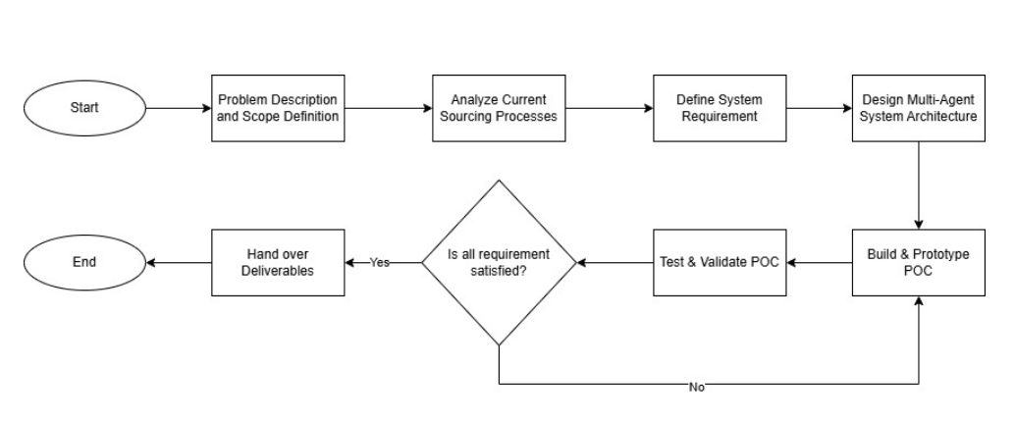
Figure 1: Plan of Work

Project Goals and Expected Outcomes
The project’s overall goal is to deliver a proof-of-concept agentic AI system which can proactively generate sourcing pipelines. To achieve this, the system will leverage a dynamic data pipeline that ingests and processes information from multiple enterprise sources. These include contract records, category strategy documents, supplier performance data, internal demand forecasts, historical negotiation data, and external market intelligence, which collectively form a comprehensive foundation for sourcing analysis and recommendations. The system will then process this data using a Multi-Criteria Decision Making (MCDM) model to evaluate and prioritize sourcing options based on defined strategic and operational criteria.
The system is designed as a human-in-the-loop agentic system, in which sourcing teams review, validate, and refine the generated pipelines rather than being replaced by full automation. Their feedback will provide the critical input needed to improve the agents over time. Working in this way, the system not only supports decision making but also learns continuously from expert oversight.
The deliverables to the company will include:
- A proof-of-concept multi-agent AI system that generates sourcing pipelines for the Sponsor’s IT Support category
- A dashboard and Application Programming Interface (API) outputs for communicating recommendations and enabling integration into existing workflows
- A comprehensive activity log capturing agent decisions, inputs, logic, and human feedback to ensure transparency, continuous improvement and performance of sourcing processes.

After implementing the POC, the Sponsor is expected to gain an initial demonstration of how sourcing cycle times could be reduced, how decision making may become more consistent, and how needs can be anticipated before contracts expire.

Assignment 2: State of the Practice and Methodology

State of the Practice
Designing an intelligent sourcing system requires understanding how sourcing decisions are made today, the analytical methods that support them, and how artificial intelligence is currently applied in procurement. This section reviews academic views on sourcing, established procurement models, current analytics and AI applications, and industry trends toward digital orchestration. Together, these insights clarify what works well today, where gaps still exist, and what capabilities a next-generation, agentic AI-enabled sourcing system must offer.

Academic and industry research describe sourcing as a structured decision process guided by clear logic, reliable data, and coordinated activities across the sourcing cycle. Classical sourcing literature treats sourcing as a design problem that aligns requirements, market conditions, supplier capabilities, and incentives to maximize value. Seshadri (2005) frames this as a mechanism design challenge where sourcing policies must coordinate prices and performance with organizational goals. More recent procurement texts position sourcing as a continuous strategic process. Monczka et al. (2020) highlight the need for integrated category strategies, cross-functional collaboration, and ongoing supplier development rather than one-time buying. These foundations show that effective sourcing depends on well-defined decision points, consistent evaluation criteria, and a stable information environment all essential for any intelligent sourcing system.

The literature also shows that different business models fit different categories and supply markets. Keith et al. (2016) outline how organizations choose among transactional, relational, and outcome-based models to drive long-term value. This suggests that an intelligent sourcing system must support more than simple price comparisons and instead enable richer evaluations of supplier capabilities, relationship structures, and value propositions.

Research on analytics and artificial intelligence demonstrates how digital tools can support these decisions. Wamba et al. (2020) explain how big data and machine learning improve forecasting, risk visibility, and operational insight. Guida (2023) highlights emerging applications such as supplier scoring, risk classification, and document extraction that help structure the early stages of sourcing. Cannas (2024) notes that these tools are increasingly embedded in procurement workflows, but their usefulness depends on high-quality, consistent, and accessible data. Current procurement systems also use optimization engines for award scenario analysis and rule-based workflows for compliance. While these tools enhance efficiency, they typically operate as isolated components and do not connect upstream requirements with downstream negotiation logic.

Industry reports point to similar trends. McKinsey (2024) shows that leading organizations now use AI-assisted recommendations to speed category strategies, spot opportunities, and shorten cycle times. Keelvar (2025) demonstrates how modern AI assistants can draft event documents, structure evaluations, and generate award scenarios while keeping processes auditable. These developments suggest that configurable digital orchestration is now possible systems can accelerate work while buyers retain decision authority.

A recurring theme across literature is the importance of responsible system design. Accenture (2025) finds that high-performing organizations rely on algorithms for consistent, repeatable analysis but reserve judgment calls, trade-offs, and approvals for humans. Effective collaboration requires transparency, feedback loops, and learning mechanisms. This aligns with the Sponsor’s requirement that the proof-of-concept system keep humans involved in key decision points rather than operating fully autonomously.

Overall, the literature reflects a clear shift from manual judgment toward data-driven and analytics-supported sourcing. However, current tools remain fragmented, with limited ability to connect reasoning across the sourcing cycle or integrate signals from contracts, demand forecasts, supplier performance, and market intelligence. This gap defines the opportunity for the project: to test whether a modular, agentic AI system can unify these elements and improve decision consistency, speed, transparency, and control within the Sponsor’s IT Support category.

Methodology
The methodology for this project is designed to provide a structured, transparent, and reproducible process for developing and evaluating a proof-of-concept intelligent sourcing system for the Sponsor’s IT Support procurement category. The approach is grounded in the Sponsor’s Desktop Procedures (DTP-01 to DTP-06), which define the sequencing, responsibilities, and compliance requirements for end-to-end sourcing activities. These procedures serve as the organizing framework for modeling the decision logic, designing the agentic system, and determining the data and evaluation needs of the POC.

Modelling the Sourcing Process
The starting point for the design is the Sponsor’s DTP 01 to DTP 06. Each procedure specifies required tasks, inputs, approvals, and checks. Rather than treating these as narrative documents, the project rewrites them as a series of explicit decisions. For each decision, the team identifies what information is required, which constraints apply, and whether the decision is fully deterministic, benefits from quantitative analysis, or primarily involves documentation and explanation.
The table below summarizes the most consequential decisions across DTP 01 to DTP 06. These decisions were selected because they shape the sourcing outcome and will later be implemented within the agentic system. The appropriate mechanism involving Large Language Model (LLM) and Machine Learning (ML) are also introduced to guide the core decision making.

DTP Phase | Core Decision | Required Inputs | Constraints | Appropriate Mechanism
DTP 01 | Select sourcing pathway | Spend, expiry, scope changes, preferred suppliers | Competitive bid policy, renewal criteria | Deterministic rule logic with LLM classification for unstructured text
DTP 01 and 02 | Identify supplier pool | Supplier master data, capabilities, performance | Risk flags, approved vendor status | Retrieval augmented search with LLM summarization
DTP 02 | Define evaluation structure | Category strategy, performance KPIs | Mandatory evaluation dimensions | Rule based validation with LLM narrative support
DTP 02 and 03 | Score suppliers | SLA history, incidents, risk indicators | Cutoff thresholds | Lightweight ML model for performance normalization and rule-based validation
DTP 03 | Generate RFx* package | Requirements, templates, evaluation matrix | Template completeness | Template driven generation with constrained LLM
DTP 04 | Recommend negotiation approach | Bids, price benchmarks, risk profile | Category policy regarding negotiation types | Heuristic negotiation rules with ML-based price anomaly detection
DTP 04 | Prepare award justification | Scores, bids, scenario comparison | Compliance documentation needs | Rule based comparison with LLM drafted rationale
DTP 05 and 06 | Produce contracting and reporting summaries | Award terms, SLAs, pricing | Required contracting and reporting fields | LLM extraction supported by rule validation
Table 1. Dynamic Sourcing Decision Modeling Across DTP 01 to DTP 06
*RFX is a general term that stands for "Request for X, and it refers to the entire category of procurement documents used to solicit bids, proposals, or information from vendors. The most common types include Request for Information (RFI), Request for Proposal (RFP), and Request for Quotation (RFQ), each with a different primary purpose in the purchasing process.
This decision mapping serves two purposes within the methodology. First, it provides a clear rationale for why certain technical mechanisms are needed and where they should be applied. Second, it establishes a direct link between the Sponsor’s sourcing logic and the system architecture that is developed in the next stage of the methodology. The mechanisms identified in the final column become the design requirements for the hybrid decision support components described in the next section. In turn, these mechanisms are later organized into functional agents that follow the DTP workflow.

Mapping Decisions to Decision Support Mechanism
The next step is to group these decisions into mechanism types that describe how the system should support them. Some decisions are entirely governed by policy and can be encoded as rules. Others benefit from retrieval of relevant information from internal documents and external intelligence sources. Some require simple analytical treatment of numerical data. Finally, several tasks involve drafting structured text that follows organizational patterns. Table 2 summarizes these mechanism types and links them back to the decision categories introduced above.

Decision Type | Description | Appropriate Mechanism
Deterministic Decisions | Decisions fully governed by policy or DTP-defined rules (e.g., sourcing pathway, mandatory criteria, contract completeness). | Heuristic rule logic and structured validation, with optional support to interpret unstructured request text
Contextual Decisions | Decisions requiring retrieval of relevant internal and external information to support human judgment. | Retrieval augmented search, grounded summarization, relevance filters, simple knowledge graph alignment
Analytics-Enhanced Decisions | Decisions benefiting from structured quantitative interpretation, using historical performance or pricing patterns. | Lightweight ML models: performance normalization (regression/tree-based) and price anomaly detection (statistical deviation). Rule thresholds always govern final eligibility.
Narrative or Documentation Tasks | Drafting RFx language, award justifications, negotiation summaries, or implementation plans. | Template-driven assembly with constrained LLM drafting; rule-based completeness checks; grounded reference insertion.
Table 2. Decision Support Mechanism by Decision Type

This mapping view confirms that the proof of concept does not attempt to automate awards or complex predictions. Instead, it uses analytic tools where they provide structure and relies on retrieval and templates where human judgment remains central.

Agentic System Design
The mechanisms described in the previous section are implemented through a set of functional agents that mirror the sequencing and intent of DTP 01 through DTP 06. Each agent supports a specific segment of the sourcing process and uses only the analytical logic required for that stage. Figure 2 illustrates how these agents interact with the data and memory layers while keeping the sourcing professional firmly in the loop.
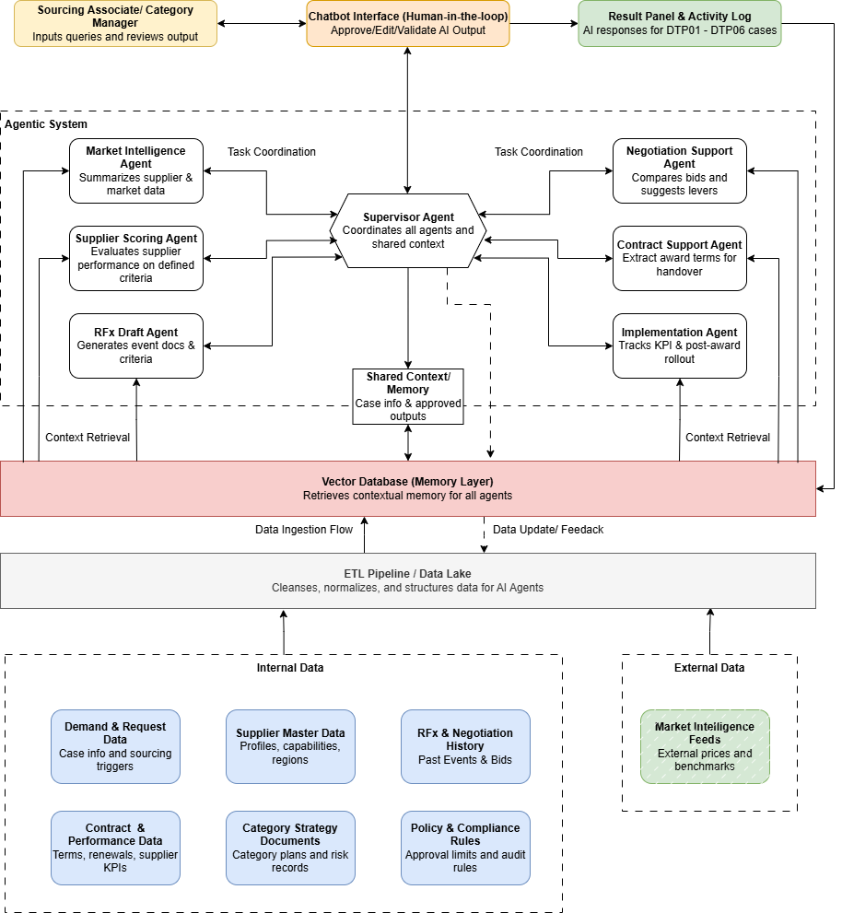
Figure 2. Overview of the Agentic AI architecture

Building on this foundation, the proof-of-concept architecture consists of a coordinated network of specialized functional agents managed by a central Supervisor Agent, all operating on top of an integrated data and memory layer. Each agent is designed to perform tasks aligned with specific DTP phases, and the Supervisor Agent ensures consistent sequencing, error checking, and integration across the full sourcing lifecycle. The detail of each agent is as follows:

Agent Name | Supported DTP Phases | Purpose in Workflow | Analytical Logic Proposed
Supervisor Agent | DTP 01–06 | Directs workflow, validates inputs, selects sourcing pathway, and orchestrates downstream agents. | Heuristic routing rules; context memory; retrieval of procedural references.
Market Intelligence Agent | DTP 01–02 | Collects internal and external market intelligence; summarizes supplier capabilities, benchmarks, and category insights. | Retrieval from internal databases and approved external feeds.  structured summarization; relevance filters.  semantic grounding.
Supplier Scoring Agent | DTP 02–03 | Converts human-defined evaluation criteria into structured score inputs; processes historical performance and risk data. | Deterministic scoring logic; ML performance normalization; rule-based eligibility checks; optional explanatory generation.
RFx Draft Agent | DTP 03 | Assembles RFx draft using templates, past examples, and structured generation based on sourcing manager inputs. | Template assembly; retrieval of past RFx materials; controlled narrative generation; rule-based completeness checks.
Negotiation Support Agent | DTP 04 | Highlights bid differences, identifies negotiation levers, and provides structured insights without making award decisions. | Structured bid comparison; ML price anomaly detection; benchmark retrieval; negotiation heuristics.
Contract Support Agent | DTP 04–05 | Extracts key award terms and prepares structured inputs for contracting and implementation. | Template-guided extraction; rule-based contract field validation; knowledge graph grounding for term alignment.
Implementation Agent | DTP 05–06 | Produces rollout steps and early post-award indicators such as projected savings and service impacts. | Deterministic calculations; retrieval of rollout playbooks; structured reporting templates.
Table 3. Functional Agents, DTP Alignment, and Analytical Logic
All agents operate on top of two shared infrastructure layers. The first is a memory layer built on a vector database, which provides contextual retrieval for each agent. The second is a structured data layer fed by an ETL pipeline that cleanses and organizes internal data sources such as supplier master records, RFx history, contract metadata, and category strategies, as well as external benchmark feeds. The entire architecture incorporates a human-in-the-loop interface (a proposed Chatbot UI), ensuring that sourcing professionals can explicitly Approve, Edit, or Reject all outputs before they are finalized.

Analytical Model Design and Learning Architecture
The analytical model used in the proof-of-concept are directly derived from the decision types identified in earlier sections. Each model type corresponds to a category of decisions in Table 1 and is implemented through one or more agents in Table 3. This section maps the analytical models to the decision they support, the agents that use them, the data they require, and the feedback signals that refine over time.
- Heuristic Rule Logic
Heuristic rules encode sourcing logic that is non-negotiable and fully defined in DTP procedures. They appear most clearly in the Supervisor Agent, where routing decisions must respect competitive bid rules and renewal criteria, and in the Supplier Scoring and Contract Support Agents, where evaluation structures and contract fields must meet minimum standards. These rules draw on structured inputs such as spend, contract expiry, supplier eligibility flags, and DTP guidance. When sourcing professionals override or correct rule driven outputs, those actions become signals that rules or thresholds may require adjustment.

- Retrieval and Knowledge-Grounded Reasoning
Retrieval models support decisions that depend on contextual understanding rather than fixed thresholds. The Market Intelligence Agent and RFx Draft Agent rely on retrieval to surface relevant policies, category strategies, supplier history, past RFx text, and approved external market intelligence. Summarization and semantic checks help convert this material into concise briefs or draft sections while avoiding mismatches in category or supplier scope. Edits and comments from sourcing professionals indicate where retrieval was incomplete, irrelevant, or unclear, and those signals inform future refinements in how documents are indexed and retrieved.

- Analytical Scoring Logic
Analytical scoring methods provide structured interpretations of historical performance data, SLA results, incident logs, audit findings, and pricing patterns. These methods support agents that must compare suppliers or interpret commercial inputs, most notably the Supplier Scoring Agent and Negotiation Support Agent. Because evaluation criteria are defined by sourcing professionals, scoring models simply standardize quantitative inputs rather than determining what should be evaluated. Adjustments made by users to these computed values serve as calibration feedback.

- Structured Language Generation
Structured generation with narrative content. The RFx Draft Agent, Market Intelligence Agent, Contract Support Agent, and Implementation Agent all use controlled drafting to produce first versions of RFx narratives, market summaries, award descriptions, and implementation notes. These drafts are grounded in templates and retrieved references and are always subject to review and editing. The volume and nature of edits provide direct feedback on clarity and completeness, and this feedback can be used to refine prompts, templates, or retrieval strategies over time.
Across all four model families, the system operates under a simple learning architecture. At the front line, the human validation loop captures how sourcing professionals edit drafts, adjust scores, flag irrelevant context or sources and override routing suggestions. At the system level, these signals inform rule updates, improvements in retrieval relevance, recalibration of scoring logic, and better phrasing of generated text. At the governance level, a small set of KPIs and KLIs, such as cycle time reduction, reliability of agent outputs, routing override rates, and edit density, help determine where agent behavior is stable and where tighter guardrails or human only decisions should remain.

Data Collection and Preparation
Data collection and preparation ensure that each agent receives consistent and reliable inputs across the sourcing lifecycle. The proof-of-concept uses anonymized Sponsor data drawn from historical sourcing events but operates fully offline and without access to live enterprise systems. The dataset includes purchase requests, supplier master records, category strategy documents, contract metadata, RFx and negotiation history, and market intelligence summaries. All data are cleansed, de-identified, and normalized into a unified schema aligned with the information requirements of DTP-01 through DTP-06.
The documents and historical sourcing records are embedded using LangChain’s text embedding models and stored in a vector database (e.g., FAISS or Chroma). This method enables agents to retrieve DTP rules, supplier history, category strategies, and contract metadata through contextual similarity search during reasoning which mitigates hallucinations.
Each sourcing phase requires specific minimum data fields. For early stages (DTP-01 and DTP-02), essential fields include category code, request type, supplier lists, contract expiration dates, spend history, and award criteria. RFx generation (DTP-03) requires structured requirements, weighted evaluation criteria, and supplier capability data. Negotiation and award simulation (DTP-04) rely on benchmark pricing, synthetic or historical bids, and performance indicators. Implementation and reporting (DTP-05 and DTP-06) require basic supplier award details, baseline and negotiated pricing, and sustainability or diversity attributes.
To ensure reliable agent reasoning, the system applies rule-based validation checks such as verifying completeness of supplier lists, confirming that award criteria sum to 100%, and ensuring pricing and performance fields fall within expected ranges. Missing or incomplete data are supplemented with controlled synthetic values to preserve logical consistency while protecting sensitive information. These preparation steps create a stable data foundation that supports predictable multi-agent behavior, consistent retrieval, and clear traceability during testing and evaluation.

Evaluation Metrics
Evaluation of the deliverable POC system performance will focus on two key measures:
- Cycle Time Improvement: This metric compares process duration before and after AI-assisted workflows, with the objective of demonstrating measurable time savings in event preparation, supplier evaluation, and related sourcing activities.
- AI Reliability: This measure assesses the accuracy, completeness, and interpretability of AI-generated outputs as evaluated by sourcing professionals. Reliability will be quantified through the proportion of recommendations accepted without modification, calculated as
$$AI Acceptance Rate= \frac{Accepted Outputs}{Total Outputs Generated}$$

These metrics are consistent with Mckinsey’s (2024) guidance that organizations should evaluate both efficiency gains and user trust when introducing AI into procurement workflows. They also align with digital transformation frameworks, which emphasize that as organizations advance toward higher levels of automation, performance measurement must capture not only process speed but also the reliability and consistency of automated decision support (Saenz, Borrella, & Revilla, 2022).
The proof of concept operates on a limited data sample and is not connected to live enterprise systems. While it uses real historical data, results may not generalize to all categories or geographies. The system’s reasoning accuracy depends on data quality and the structure of the vectorized knowledge base. Human review remains mandatory for all outputs to prevent unintended decisions or policy deviations. This cautious approach reflects current best practices for responsible adoption of AI in sourcing (Accenture, 2025).

Development Process
The development process below extends that framework with more detailed steps tailored to building and validating a multi-agent AI prototype. The prototype uses LangChain, a framework that simplifies document retrieval and controlled language generation, along with LangGraph, a lightweight orchestration tool that allows the agent workflow to be represented as a clear sequence of interconnected steps The development and testing cycle consists of the following steps:
- Use Case Definition: The team selects three to five representative IT Support sourcing events that capture the range of decisions across the DTP sequence. These events become the simulated cases used to exercise the prototype and observe agent behavior in realistic scenarios.
- Prototype Build: The multi agent workflow is assembled in a local development environment. During this phase, the team configures the decision logic for each agent, connects the workflow to prepared data sources, and confirms that routing, retrieval, and scoring behave as intended. LangChain components support retrieval and prompt management, while LangGraph provides a simple way to express the workflow as a sequence of agent steps. These tools allow the team to focus on testing logic rather than engineering infrastructure.
- Verification Through Simulation and Testing: The full workflow is executed end to end across the selected use cases. This allows the team to observe how agents interact, how state flows from one step to another, and how consistent the reasoning is when the same case is run multiple times. Trace logs from LangChain and execution views from LangGraph help confirm that retrieval paths, rule triggers, and narrative generation behave as expected and that no unintended variation or hallucination emerges.
- Performance Recording: Capture cycle time per sourcing phase and AI reliability metrics.
- Iterative Feedback and Refinement: Incorporate qualitative feedback from sourcing professionals to improve prompts, logic flow, and transparency.
This structured process ensures that the POC evolves through controlled iteration, consistent with how enterprise AI solutions mature from concept to pilot deployment.

Expected Outcomes
This methodology is designed to validate whether dynamic sourcing decisions can be modeled, supported, and accelerated through a combination of rules, retrieval, lightweight analytics, and structured generation. The proof-of-concept is expected to show whether sourcing decisions across DTP-01 to DTP-06 can be made more consistent, faster, and easier to manage through a combination of rules, retrieval, lightweight analytics, and structured generation.
To measure the success of this validation, we rely on two types of metrics:
- Key Performance Indicators (KPIs): These measure the quantitative benefits and efficiency gains resulting from the AI-assisted workflow (e.g., measurable time savings or acceptance rates).
- Key Learning Indicators (KLIs): These capture qualitative feedback and behavioral data that help refine the agentic system and define requirements for future scaling (e.g., override patterns and edit density).
The expected outcomes are organized as follows:
- More Consistent and Transparent Decisions
The POC should demonstrate that repeatable sourcing steps such as pathway selection, supplier scoring, RFx drafting, and bid comparison can be executed more uniformly with clear logic and traceability.
- KPI: AI Reliability Rate: % of outputs accepted without major edits.
- KLI: Override Patterns: when and why users adjust system logic.

- Reduction in Early-Phase Cycle Time
The system is expected to shorten the most manual parts of sourcing: consolidating data, identifying suppliers, preparing RFx documents, and generating comparisons.
- KPI: Cycle Time Reduction from DTP-01 to DTP-03.

- Stronger Human–AI Collaboration
The POC reinforces a human-in-the-loop model, where AI handles repetitive and retrieval-heavy tasks while sourcing managers focus on judgement and refinement.
- KLI: Edit Density: degree of user editing across drafts.

- Earlier Visibility Into Upcoming Sourcing Needs
Even in an offline environment, the system should show how dynamic rules can surface early signals from contract expirations, spend thresholds, and supplier attributes.
- KPI: Timeliness Improvement: earlier identification of required events.
- KLI: Pipeline Signal Accuracy: correctness of rule-driven triggers.

- Clear Insights for Scaling Beyond the POC
The POC will reveal data quality requirements, which agents provide the highest value, and where guardrails or revised rules are needed before any enterprise rollout.
- KPI: Data Completeness Score: % of required fields available.
- KLI: Agent Stability: consistency of outputs across repeated runs.
Overall, these KPIs and KLIs help determine where the system creates measurable benefits today and what additional capabilities will be required to scale a dynamic, agentic sourcing system responsibly.
The scope of the methodology is intentionally bound. The POC operates entirely in an offline environment using anonymized historical data and focuses solely on analytical, decision-support, and workflow-generation activities. It does not execute live sourcing events, interact with production systems, or replace any formal approvals, ensuring that the work remains both responsible and aligned with the Sponsor’s operational constraints. With these boundaries defined, the methodology provides a disciplined way to explore where hybrid AI components can meaningfully support dynamic sourcing decisions while maintaining human oversight.

References
Accenture. (2025). Learning Reinvented: Accelerating Human-AI Collaboration. Retrieved from www.accenture.com: https://www.accenture.com/us-en/insights/consulting/learning-reinvented-accelerating-human-ai-collaboration
Cannas, V. G. (2024). Artificial Intelligence in Supply Chain and Operations Management. International Journal of Production Research. doi:10.1080/00207543.2023.2232050
de Weck, O., Roos, D., & Magee, C. (2011). Engineering systems: Meeting human needs in a complex technological world. Cambridge, MA: MIT Press.
Guida, M. (2023). The Role of Artificial Intelligence in the Procurement Process. Computers in Industry, 103982. doi:10.1016/j.compind.2023.103982
Keelvar. (2025). The Rise of AI Agents in Enterprise Procurement. Retrieved from www.keelvar.com: https://www.keelvar.com/documents/the-rise-of-ai-agents-in-enterprise-procurement
Keith, S. C., Vitasek, K., Manrodt, K., & Kling, J. (2016). Strategic Sourcing in the New Economy: Harnessing the Potential of Sourcing Business Models for Modern Procurement. London: Palgrave Macmillan.
Mckinsey & Company. (2024). Revolutionizing Procurement: Leveraging Data and AI for Strategic Advantage. Retrieved from www.mckinsey.com: https://www.mckinsey.com/capabilities/operations/our-insights/revolutionizing-procurement-leveraging-data-and-ai-for-strategic-advantage
Monczka, R. M., Handfield, R. B., Giunipero, L. C., & Patterson, J. L. (2020). Purchasing and Supply Chain Management. Boston: Cengage Learning.
Russell, S. J., Norvig, P., Chang, M.-W., & Devlin, J. (2020). Artificial Intelligence: A Modern Approach (4th ed.). Hoboken, NJ: Pearson.
Saenz, M. J., Borrella, I., & Revilla, E. (2022). A framework for digital supply chain transformation. Cambridge, MA: MIT Center for Transportation & Logistics.
Seshadri, S. (2005). Sourcing Strategy: Principles, Policy and Designs. New York: Springer.
Wamba, S. F., Gunasekaran, A., Dubey, R., & Ngai, E. (2020). Big Data Analytics and Artificial Intelligence in Operations and Supply Chain Management: A Review and Future Research Agenda. International Journal of Production Economics, 229, 107774. doi:10.1016/j.ijpe.2020.107774

